

Payment Cartridge Test Cases

***bm_checkoutcom***

# Table of Contents

1. Summary 2
2. Check the BM Module 3
3. Business manager: check the order details 4

* 1. **Introduction**

Once the cartridge installed and configured as described in the documentation, you can proceed with a test transaction.

In order to make sure the installation and BM module functionality is working as expected, 3 simple steps are required:

1. Open Checkout.com Transactions section from “Checkout.com Manager”.
2. Perform the void, capture and refunds for the transactions.
3. Check the actions details in Order

# Open BM Module

**Step 1**. Open the BM Module for checking the transaction status.

With the use of this Module we can void, capture and refund the transactions.

**We can also perform partial refunds and partial captures.**

**NOTE : Partial refunds are supported by both the platform. And partial captures are only supported by the NAS platform.**

**Partial Capture Scenario: If we do a partial capture, then we can do a refund for the partial captured amount.**

**For Example: Refunds can be processed to the total amount captured. i.e. if GBP 100 was authorised and only a total of GBP 50 was captured, then the merchant can refund GBP 50**

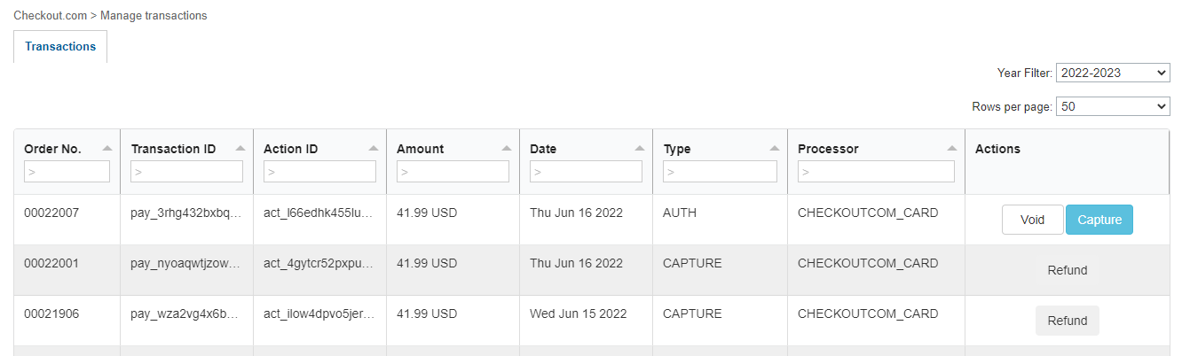

**Step 2.** Perform an action.

i) Void the transaction : When we click on the void button pop up is open for void the transaction.

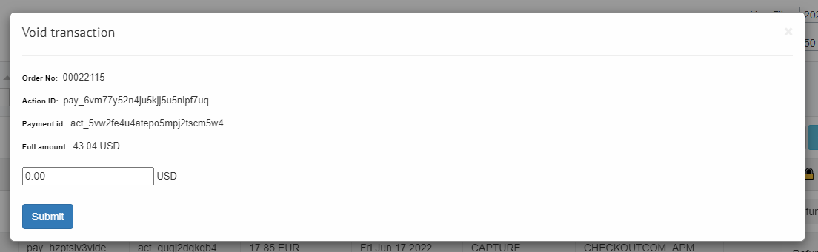

After submit, void of the transaction is processed and the transaction is locked.

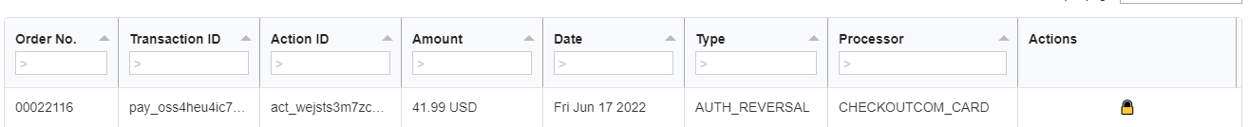

ii) Capture the transaction: When we click on the capture button pop up is open for capture the transaction.

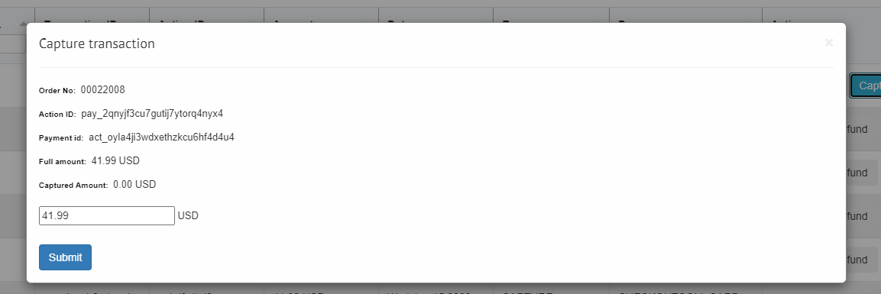

After submit, capture of the transaction is processed.

We can also refund after capture of the transaction.

iii) Refund the transaction: When we click on the refund button pop up is open for refund the transaction.

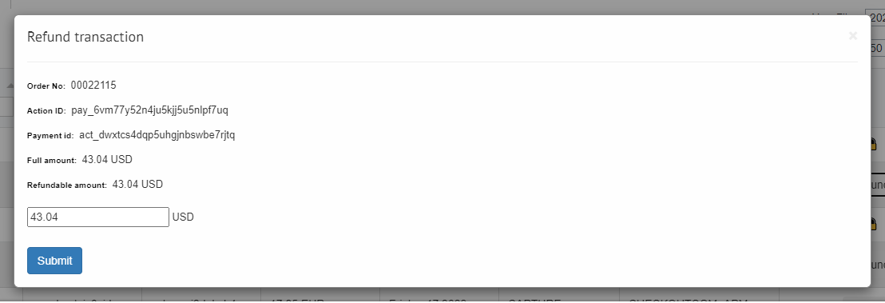

After submit, refund of the transaction is processed.

# Check the order

Access the order list in the Business Manager: Merchant Tools > Ordering > Orders

A order should be available, with an order number corresponding to the one you have Void, Captured and Refund. Click on it to view the order details.

On the payment tab of the order details, you should find information related to the Checkout.com payment method.

The “Payment Method” section of the tab should contain the following information for the transaction action type:

1. Void Transaction

CHECKOUTCOM_CARD

Processor: CHECKOUTCOM_CARD

Transaction: <your_transaction_id>

Amount: <amount_of_your_order>

Checkout.com Parent Transaction ID:

<your_transaction_id>

Checkout.com Transaction Type: Void

Checkout.com Transaction Opened: false

Checkout.com Action ID: <your_action_id>

1. Capture Transaction

CHECKOUTCOM_CARD

Processor: CHECKOUTCOM_CARD

Transaction: <your_transaction_id>

Amount: <amount_of_your_order>

Checkout.com Parent Transaction ID:

<your_transaction_id>

Checkout.com Transaction Type: Capture

Checkout.com Transaction Opened: true

Checkout.com Action ID: <your_action_id>

1. Refund Transaction

CHECKOUTCOM_CARD

Processor: CHECKOUTCOM_CARD

Transaction: <your_transaction_id>

Amount: <amount_of_your_order>

Checkout.com Parent Transaction ID:

<your_transaction_id>

Checkout.com Transaction Type: Refund

Checkout.com Transaction Opened: false

Checkout.com Action ID: <your_action_id>

# Check the transaction

The transaction details should be available in the order for a successful payment. In the order details click on the “Notes” tab to view the transaction details.

You should have the details of the transaction, similar to the following:

1. For Void:

cko.webhook.event: payment_voided

Transaction ID: <your_transaction_id>

cko.transaction.paymentId: <your_payment_id>

cko.transaction.eventId: <your_event_id>

Response code: 10000

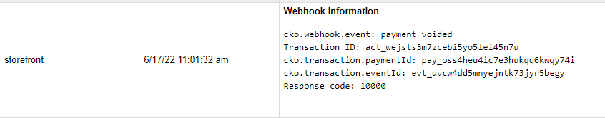

1. For Capture:

cko.webhook.event: payment_captured

Transaction ID: <your_transaction_id>

cko.transaction.paymentId: <your_payment_id>

cko.transaction.eventId: <your_event_id>

Response code: 10000

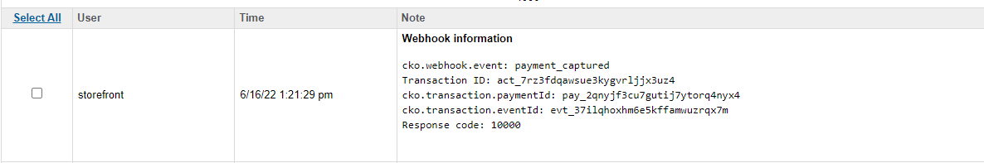

1. For Refund:

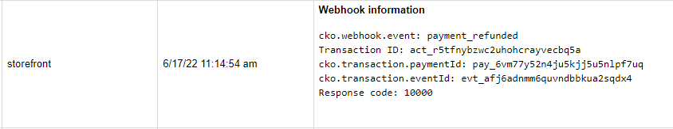

You should have one note related to a particular void, capture, and refund with the response code 10000. This code confirms a successful void, capture and refund of the transaction.

With the response code 10000, the cartridge can be considered as working as expected.